Halloween Word Search
Find the missing word
W F S F C C R J I E N I K P M U P T D X
B I V P J X S C N S Y A O Y P E W D E I
A X Z I I T U O J E V K F R D J D S V E
B C F A E D T U D B W J A Y V S K Q J I
P I F E R S E X K C S G D W U E B D X B
E J W U E D P R J A C W C A D D C R V M
G S O V X J D H W S G E U T G B N A J O
L Q A L Z T P F X E G R K A A K M Q R Z
F R R N D X W P E Z B E T F Y P J B C E
G K C I R T D I G S W W B A I C D W N R
U E S G R G C H H K A O I R E I H S Q A
Q C G H Z B H L O D Z L E B R R S N Y C
X I N L J Q A X S B E F J M S W T I E S
P H J Y I V R M T U S T L E I B A P A Y
H A L L O W E E N P K B N T P H Q S P S
J U A X O B Z X G D H N C U Z K K Q F F
T N F O Y M D T R R L H J Q A M G R S O
K B I V L S J C X U X I Z Q O H A F G W
U U B C J Q A Z Q D T F B Z E O J B E Y
I B R C B V Z V F G B Q W L F R I G H T

FRIGHT
GHOST
GRAVESTONE
HALLOWEEN
HAUNTED
PUMPKIN
SCARE
SPIDERWEB
SWEETS
BLOOD
TREAT
TRICK
VAMPIRE
WEREWOLF
WITCH
WIZARD
ZOMBIE

Halloween Word Scramble
Unscramble the below to find the Halloween words
AENLELOWH
HATEUDN SOHEU
JKCA O RLANNET
KMPPUINS
HGTSO
IWHCT
IZRAWD
ARGEV RYSDA
RSENOSMT
NOCUT LUADARC
OBEMIZ

LAESYLBE

WISRSPEBED

DEONM

LBAKC TAC

Answers: Halloween; Haunted House; Jack o Lantern; Pumpkins; Ghost; Witch, Wizard, Grave Yard, Monster, Count Dracula, Zombie, Eyeballs, Spiderweb, Demon, Black Cat

Halloween Crossword
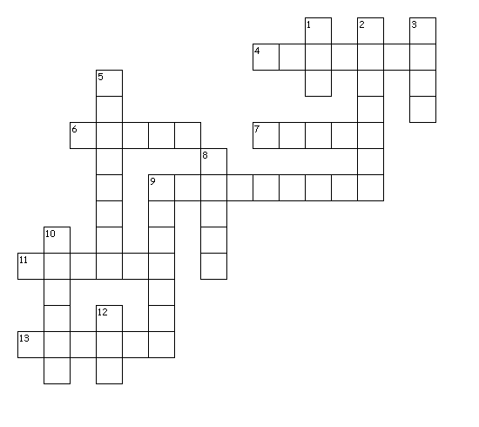
Across

4. The name of the famous vampire
6. Witches mode of transport
7. Finish the sentence _____ or treat
9. October 31st
11. Where a vampire sleeps
13. This person creates spells and has a long beard

Down

1. Witches pet
2. You carve this vegetable into scary faces
3. What name goes before ______ o'lantern
5. Comes out on a full moon
8. What do vampires drink
9. When a house is filled with ghosts its called a ________ house
10. They tend to eat other people brains
12. Vampires can turn into these night time creatures

Answers: Halloween; 1. Cat, 2. Pumpkin, 3. Jack, 4. Dracula, 5. Werewolf, 6. Broom, 7. Trick, 8. Blood, 9. Halloween, 10. Zombies, 11. Coffin, 12. Bat, 13. Wizard,

